Activity 1. Just Bead It – Sorting, Classifying, and Counting
Concepts and skills taught: sorting, classifying, counting, writing numerals
Grade Level: K/1
Math standard: Number and Operations
Materials required: Colored beads, colored pencils or crayons

- Native American beadwork uses designs and colors to tell a story that was in the mind of the beadworker who made it. Think of a story you want to tell with colors you select and patterns you create. Color in the grid to create your story and design. Keep this design handy because you will use it for a number of other math activities.

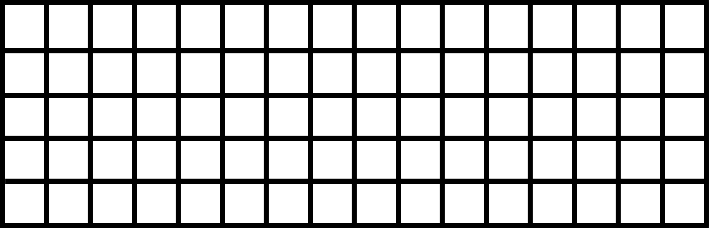

- What story is your beadwork telling?

- Place a bead in each grid square to match the color of the square in your design. After the design has been filled, sort the beads you have used into groups according to color. For instance, group all the red beads, the white beads, and so on.

- Count the number of beads of each color you have used and write that number next to the color name below:

Red_____ White_____ Black_____ Yellow_____

Dark Blue_____ Light Blue_____ Dark Green_____ Light Green_____

Purple_____ Orange_____ Pink_____ Other color____ Other color_____

