CSDT Test Name_______________________________________

A. Place the letter of the phrase that describes each term (total 10 pts).

__Cartesian Coordinate System A. numbers less than zero

__Symmetry B. a system that names the mathematical
location of intersections on a plane
__Quadrants
C. The same on both sides of an axis

__X axis D. numbers greater than zero

__Y axis E. the intersection of the x axis and y axis

__Positive numbers F. two numbers that show the position of a
point on a grid

__Negative numbers G. the horizontal axis of a plane

__Ordered pairs H. the vertical axis of a plane

__Intersection I. a point on a plane where two lines cross

__Origin J. the four portions of a plane as divided
by the coordinate axes

B. What is iteration? (total 2 points)

------------------------------------------------------------------------------------------------------------------------------------------------------------------------------------------------------------------------------------------------------------------------------------------------------------------------------------
C. Comprehension of Concepts. (total = 12 pts.)

- Write the number of the quadrant (1-4) for each colored bead.
White _____ Black _____ Gray _____ Spotted ____

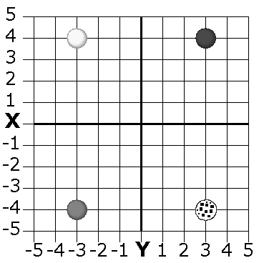

- Write the ordered pair for each bead on the grid.
White _____ Black _____ Gray _____ Spotted ____

- Draw a bead on the grid for each ordered pair. Color the beads, or write the name of the color next to the bead
White -2,3 Black -3,-3 Gray 4,1 Spotted 1,-2
