Virtual Beadloom Design Tool Post-Test. Name________________________

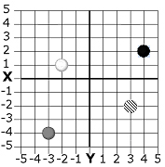
- Write the ordered pair (X and Y coordinates) for each bead on the grid.
White _____ Black _____ Gray _____ Striped ____

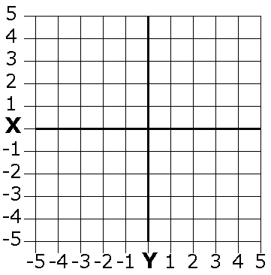
- Draw a bead on the grid for each ordered pair. Color the beads, or write the name of the color next to the bead
White -1,5 Black -2,-4 Gray 1,3 Striped -2,1

- Fill in the triangle whose corners are at the following three ordered pairs:
1,1 1,4 4,1

4. Question 3 asked you for a triangle whose corners are at the following three ordered pairs: 1,1 1,4 4,1
What are the ordered pairs that give us the same triangle, reflected across the X axis?

