Virtual Beadloom Design Tool Pre-Test. Name________________________

Have you ever use the “Virtual Beadloom” before? ___Yes ___No

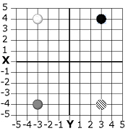
- Write the ordered pair (X and Y coordinates) for each bead on the grid.
White _____ Black _____ Gray _____ Striped ____

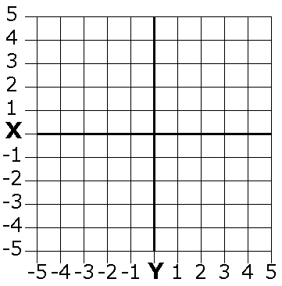
- Draw a bead on the grid for each ordered pair. Color the beads, or write the name of the color next to the bead
White -2,3 Black -3,-3 Gray 4,1 Striped 1,-2

- Fill in the triangle whose corners are at the following three ordered pairs:
1,1 1,4 4,4

- Question 3 asked you for a triangle whose corners are at the following three ordered pairs: 1,1 1,4 4,4
What are the ordered pairs that give us the same triangle, reflected across the Y axis?

