Virtual Beadloom Design Tool Pre-Test for Students in Grades 3-5.

Name_______________________________________

Part 1. Vocabulary (matching – place the letter of the phrase that describes each term) Scoring would be one point for each correct response (Total for Part 1 = 11 pts.)

__Cartesian Coordinate System A. a line that runs parallel to the horizon

__Vertical line B. numbers less than zero

__Horizontal line C. a system to name the mathematical location of intersections on a plane

__X axis D. a line that is at a right angle to the horizon

__Y axis E. the horizontal axis of a plane

__Positive numbers F. the vertical axis of a plane

__Negative numbers G. two numbers that show the position of a
point on a grid

__Ordered pairs H. numbers greater than zero

__Intersections I. the intersection of the x axis and the y axis

__Origin J. the point on a plane where two lines cross

__Quadrants K. the four portions of a plane that is divided
by the coordinate axes
Part 2. Comprehension of Concepts. Scoring would be one point for each correct response (Total for Part 2 = 12 pts.)

- Write the number of the quadrant (1-4) for each colored bead.
White _____ Black _____ Gray _____ Spotted ____

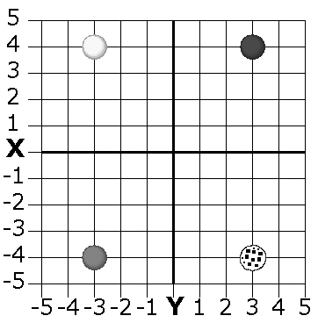

- Write the ordered pair for each bead on the grid.
White _____ Black _____ Gray _____ Spotted ____

- Draw a bead on the grid for each ordered pair. Color the beads, or write the name of the color next to the bead
White -2,3 Black -3,-3 Gray 4,1 Spotted 1,-2
