Virtual Bead Loom Workbook for Middle School (grades 6-8)

We are going to begin a study of beadwork. You will be able to create your own beadwork patterns on the computer, and turn these patterns into real beadwork.

We will start with a website called “Culturally Situated Design Tools.” It is located at http://www.rpi.edu/~eglash/csdt.html

Click on Virtual Bead Loom. Read the first page and then click on “continue” at the bottom right, which will enter you into the section on cultural background. Read through this section and answer the questions below.

CULTURAL BACKGROUND

Look at the four images of Native American designs under the first page of cultural background. The four designs represent different tribes from different areas. Symmetry was extremely important in the creation of art and artifacts made by the Native Americans.

Looking at the four examples in this page, what geometric designs or features do you see?

Embroidery, Plains Indians: _____________________________

Shoshone Beadwork: ___________________________________

Pawnee Buffalo Hide Drum: _____________________________

Sand Paintings, Navajo: _________________________________

What geometric features are common in all four examples?

________________________________________________________________________

________________________________________________________________________

________________________________________________________________________

Symmetry is a geometric term which means that two things look the same. Reflection symmetry means that one part of a shape is the mirror image of another part. For example, look at the first example of embroidery work done by a Plains Indian. There are two lines of symmetry. If you draw a line vertically through the upper two triangles, what you have on one side of the line will match what you have on the other side of the line. Also, if you draw a horizontal line between the left two triangles, again you will have a line of symmetry where the upper half will be a reflection of the lower half.

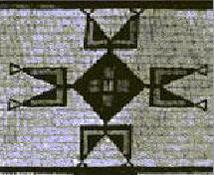

Now look at examples two through 4 on the tutorial. How many lines of symmetry are there in each example?

Shoshone Beadwork: ______________________

Pawnee Drum: ___________________________

Sand Painting: ___________________________

Continuing the tutorial, click on continue and read about reflection symmetry and four fold symmetry.

What is four fold symmetry?

________________________________________________________________________

________________________________________________________________________

In your previous classes, you have studied about graphing ordered pairs onto the coordinate plane. You will need to use this knowledge to create your virtual bead work.

REVIEW OF COORDINATE PLANE AND GRAPHING

The coordinate plane is called the “Cartesian Coordinate system” because it was introduced by a French mathematician named Rene Descartes in 1637. But in the bead loom website we saw that it was used hundreds of years before Descartes was born by the native peoples in what is now Northern and Central America. Should it be renamed the “Native American Coordinate System”? Why or why not?

_______________________________________________________________________

________________________________________________________________________

With the knowledge of the coordinate system, Descartes and his colleagues showed how you can plot equations as points, lines, and curves. Native Americans also developed ways to create geometric forms by plotting points (beads) on a grid (the bead loom!).

Number Line: X

On a number line, each point is the graph of a number. So the number 4 would be represented with an X over the 4 on the number line.

On a plane each point is the graph of an ordered pair (X,Y)
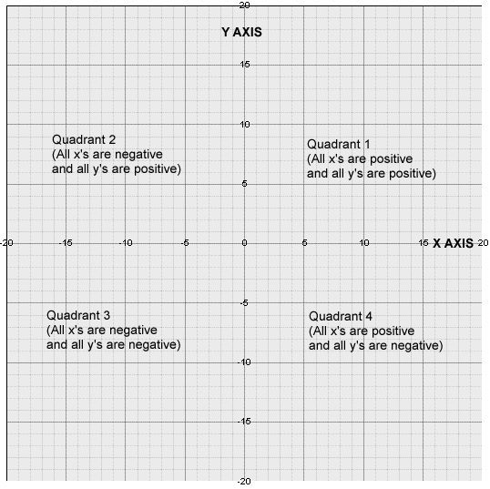
We use two perpendicular number lines called axes, which divide the plane into four regions called Quadrants. The horizontal axis

is called the X axis and the vertical axis is called the Y axis.

The axes cross at a point called the origin. The numbers in an ordered pair are called coordinates. The X coordinate ALWAYS goes first, like in the alphabet. If a point is labeled (5,6), this tells you that you start at the origin and you go right (towards the positive numbers) 5 units. Then you go up 6 units and that is where point (5,6) is found.

Is the point (5,6) the same as the point (6,5)? Why or why not?

______________________________________________________

______________________________________________________

What about (5,6) and (-5,6). Are these the same points? Why or why not?

Which quadrant is (5,6) found in? _____________________

Which quadrant is (-5,6) found in? _____________________

All the points on the X axis have what number for the Y coordinate?

______________________________

All the points on the Y axis have what number for the X coordinate?

___________________________________________________

Continuing on in the tutorial, click on continue and read about Sand Paintings.

How are sand paintings similar to a Coordinate Plane?
________________________________________________________________________

________________________________________________________________________

Click continue

Why do you think it is important for the Yupik to have both sides of their parka look the same?

________________________________________________________________________

________________________________________________________________________

Click continue

How is the bead loom also like the Cartesian coordinate Plane system?

________________________________________________________________________

________________________________________________________________________

Describe the Great Chain beadwork:
________________________________________________________________________

________________________________________________________________________

________________________________________________________________________

Why did the Iroquois give it to the US Government in 1794?

________________________________________________________________________

________________________________________________________________________

________________________________________________________________________

How are beads placed on a bead loom?

________________________________________________________________________

________________________________________________________________________

EXPLORING THE VIRTUAL BEAD LOOM

Lets try it out. Click on “software” in the left-hand menu and you will see the virtual beadloom applet. Move your mouse so that your arrow cursor moves around the grid, and you can see the numbers in the upper right corner change. Those numbers are the coordinates of the arrow. Go to the “options” menu and select the first option, “XY follows mouse.” Now select the last option, “Close menu.” Now move the arrow around the grid and you can see the numbers change right over the arrow.

Try putting your arrow over the point (2,2). That tells us to go 2 units to the right of the origin, and 2 units up from the origin.

Now lets make some beads! Go to the drop-down menu at the right, which says “point” and click on “create.” You have now created a bead at x=2, y=2. Try changing the x and y numbers and click on “create” again. You will have a new bead in that new coordinate location. Click on the little colored square next to the bead and the click on “create” again; you will see your bead color change. Try creating a little pattern of your own using this “point” tool.

Now click on the drop-down menu so you can change it from “point” to “line.” A line of beads has two endpoints. So if you use this tool and enter (0, 3) and (0, 7), it will tell the computer to put a vertical line of beads on the X axis, from y=3 up to y=7. You will have beads at (0,3), (0,4), (0,5) (0,6) and (0,7).

Now try creating the first letter of your first name using the line tool. What are the coordinates for the endpoints of lines that create the first letter of your first name?

Now try the “triangle” and “rectangle” selections in that same drop-down menu. You just have to tell it the coordinates for the vertices (corners) of the shape, and it fills in the rest. What are the coordinates for a rectangle that fills the entire screen?

________________________________________________________________________

Now try “linear iteration” ” in the drop-down menu. Iteration is a mathematical term meaning “cycles of output” – each new output builds on the previous output. Each iteration builds a new row of beads. If you click on “create” using this linear iteration tool’s default values (the numbers that are already in it when you first try it out), what geometric shape do you get?

In this pattern, you have a rule that says each time you build a new row of beads; you copy the old row, remove a bead from the 1st end, and add a bead to the 2nd end.
Which numbers do you have to change if you want to get an isosceles trapezoid using linear iteration?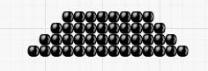__________________________________________

Now lets try “triangle iteration” in the drop-down menu. What kinds of triangles can be created with this tool? What kinds of triangles cannot be made with this tool?

______________________________________________________________________

______________________________________________________________________

Could you model Mexican pyramids as iterations? cornrow hairstyles? Why? To explore this question in depth, go back to the “Culturally Situated Design Tools” homepage at http://www.rpi.edu/~eglash/csdt.html

________________________________________________________________________

Extra credit: The Equilateral Triangle Challenge

At first you might think that you can create an equilateral triangle by having the same number of beads on each side. But since the beads are on the intersections of a square grid, the distance between beads on the diagonal is greater than those on the horizontal or vertical. Try the “triangle iteration” tool using the rule “after every 1 row add 1 to both ends and you can see how there is a gap between the beads along the diagonal.

Now go back to the “triangle” tool (not the “triangle iteration” tool, but the one that lets you enter coordinates of the 3 vertices). See if you can figure out the values for coordinate pairs that produce an equilateral triangle. (note: you may want to go to the “options” menu and resize the grid so you can use bigger numbers).

_______________________________________________________________________

CREATING YOUR BEAD WORK ON THE VIRTUAL LOOM

Now you will create your own beadwork.

Remember when you enter the coordinates; you must click on the “create” button to see the bead. If you make a mistake you can use the “undo” button at the top menu (top menu in the bead loom applet, not the menu in the browser). If you use the “remove” button it will remove all the beads in that area, not just the most recent ones, so for undoing mistakes always use “undo.” Also be sure you try out the “save” function from that same top menu and make sure it works. You don’t want to spend hours making a design and then accidently let it get erased. Always save your data frequently, just in case the computer crashes. You can use that same top menu to get more options as well as print your design.

NOW COMES THE FUN! Create five awesome beadworks (you can create more if you like) and print them up and attach them to this workbook. If your school printer is not in color, you might want to save your work so you can place it on a disk and take it home to print on your color computer. For saving an image of your design on the computer click on “tutorial” in the right hand menu and read the instructions at bottom.

When you have finished creating patterns and designs, select your favorite design: you will re-create it using the traditional beadwork techniques.

PHYSICAL BEADWORK

There are two ways to create physical beadwork. One way is to use a loom; the other way is to use the “lacing” method. There are instructions for both at http://www.ccd.rpi.edu/eglash/csdt/na/loom/classrm/pb_tips.htm

Some nice examples are online at http://www.ccd.rpi.edu/eglash/csdt/na/loom/classrm/ms_sw.htm

BEADWORK BATTLESHIP

You may have played the game of battleship using paper and pencil. Playing it with the virtual bead loom gives you some new possibilities.

- Try it the old fashioned way: create a 10 by 15 (or 15 by 10) beadwork rectangle somewhere on the screen, and pair up with a partner who does the same. Take turns calling out coordinate points: whoever gets 3 hits wins.
- Now try it the fancy new way using lasers (the line tool!). Your line tool needs two end points, so you get to call out two coordinate pairs. What attack strategy can you use to make sure your laser beams cover as much of the board as possible? What defense strategy can you use if you assume your opponent will make this attack? To make your game a little more challenging, you might want to go to the “options” menu and resize the grid.
- To make the game mathematically challenging, try specifying lines by calling out equations in the form y=mx+b, where b is the place where it crosses the Y axis (the “y intercept”) and m is the slope.
- Invent your own version using any of the tools and your own set of rules. Anyone for a quick game of linear iteration battleship?

