Culturally Situated Design Tools: http://www.rpi.edu/~eglash/csdt.html

Culturally Situated Design Tools are a suite of free, web-based interactive applets that allow students and teachers to explore ethnomathematics through the simulation of cultural artifacts such as Native American beadwork, African sculpture, and Latino percussion rhythms. Grade levels range from 4 to 12. Each site includes a cultural background section, a tutorial, the software itself, and a “teaching materials” section of lesson plans and evaluation instruments for integration into standards-based curricula.

Example: Virtual Beadloom:
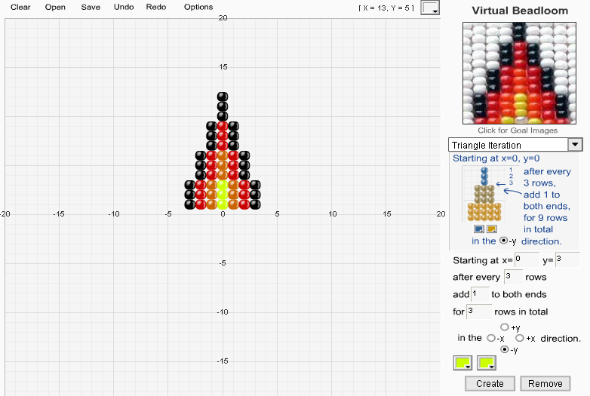
Math topics: Cartesian coordinates, transformations, analytic geometry, slope, angle, perimeter, area, percentage, iteration.

Sample problems:
1) Create a right triangle in the first quadrant.
a. If we make a copy of this triangle using reflection across the Y axis, what are its new coordinates? Which quadrant is it in?
b. If we make a copy of this triangle using reflection across the X axis, what are its new coordinates? Which quadrant is it in?
c. How can we use reflection to create a fourth triangle that is in a different quadrant than either of the two above? What are its coordinates?
d. What would be a general rule for determining the new coordinates of any triangle created by reflection?

