Transformation Quiz ____________________

(1) Label the quadrants in the Cartesian coordinate system I, II, III, and IV



Do you think our work on transformations and symmetry with the Virtual Beadloom helped you learn this?

(2) Use the transformation (x,y) → (x,-y) to transform the figure:

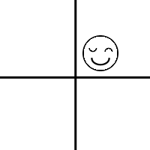

Which type of transformation is this?

How did our work with the Virtual Beadloom help you understand this?
(3) Use the transformation (x,y) → (-x,-y) to transform the figure:

Which type of transformation is this?

(4) (x,y) → (x, -y) will transform the figure into which quadrant?

Which type of transformation is this?

How did our work with the Virtual Beadloom help you understand this?
(5) Label all lines of reflection, translation, vectors, and ___-fold rotation geometries:

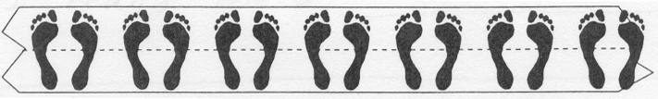

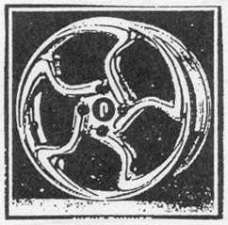

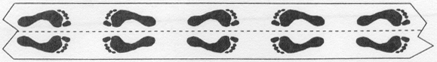

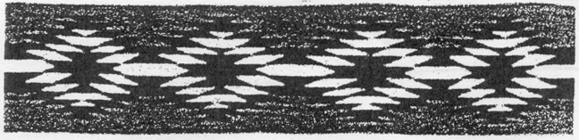
(6) Please offer some advice to the programmers who wrote and would like to improve the Virtual Beadloom:

- i. I really liked:

- ii. They are already working on making it so you could print or save your work. What other change would you like to see?

- iii. Explain or describe the program for someone who has not seen it:

- iv. Other comments:

