Graffiti Name Tags
Even if you only have time for the kids to make one letter, you can paste it into Word, Paint or other applications and print them out as unique name tags.
Tips:
Press the “print screen” button in Windows to copy the graffiti design to the clip board, and then paste it into a blank page in photoshop or Paint. Then you can crop out just the letter.
in word you can click on the image and under “text wrapping” select “behind text.” That will allow you to move the image where you like in relation to the text.
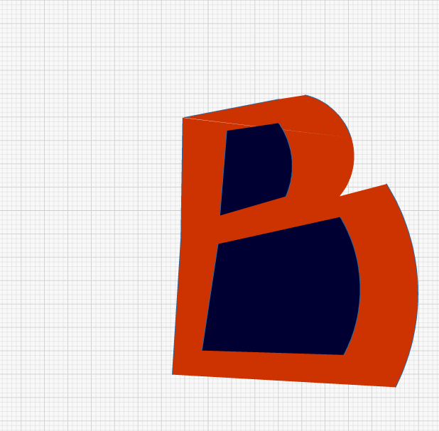

Ms. eyondi

