Louis Martinelli (RPI student)
Kirsten Wojtowicz (teacher: kwojtowicz@ArkCharter.org)

From Virtual Pyramids to Paper Pyramids in a 6th grade Math Class

Materials – Paper (preferably 8.5 X 11), Scissors, Tape, and a Ruler

In this exercise students created virtual pyramids using the Pre-Columbian Pyramids design tool (http://www.rpi.edu/~eglash/csdt.html). Then they created paper “bricks” of the same proportions as one of the virtual bricks. By stacking many of these bricks together they built a physical version of one of the virtual pyramids. Virtual pyramid tips, brick-making instructions, and math curriculum connections follow below.

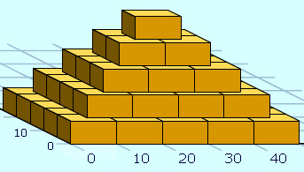 | 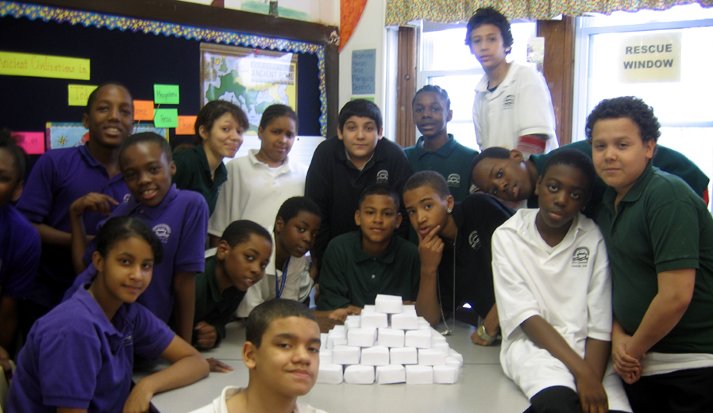

Tips on making virtual pyramids:

--To get bricks on each layer to overlap (rather than align with) the bricks in the layer below, use - 0.5 (or other fraction) for the iteration values rather than a whole number.
--To get a staircase (cf. http://www.rpi.edu/~eglash/pr/temple1.jpg) use -1 front ,+1 back (or other +/- combination) for the iteration values.

Brick-making instructions:
Step 1: Take a piece of paper and Cut into a square with equal sides | 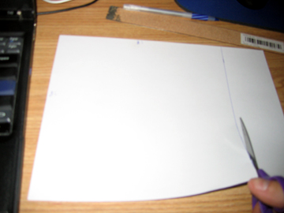
Step 2: Fold on diagonal evenly so corners meet to make a triangle | 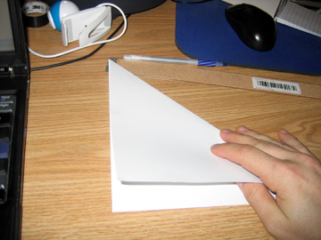
Step 3: Take the triangle and fold in half so the base meets the top | 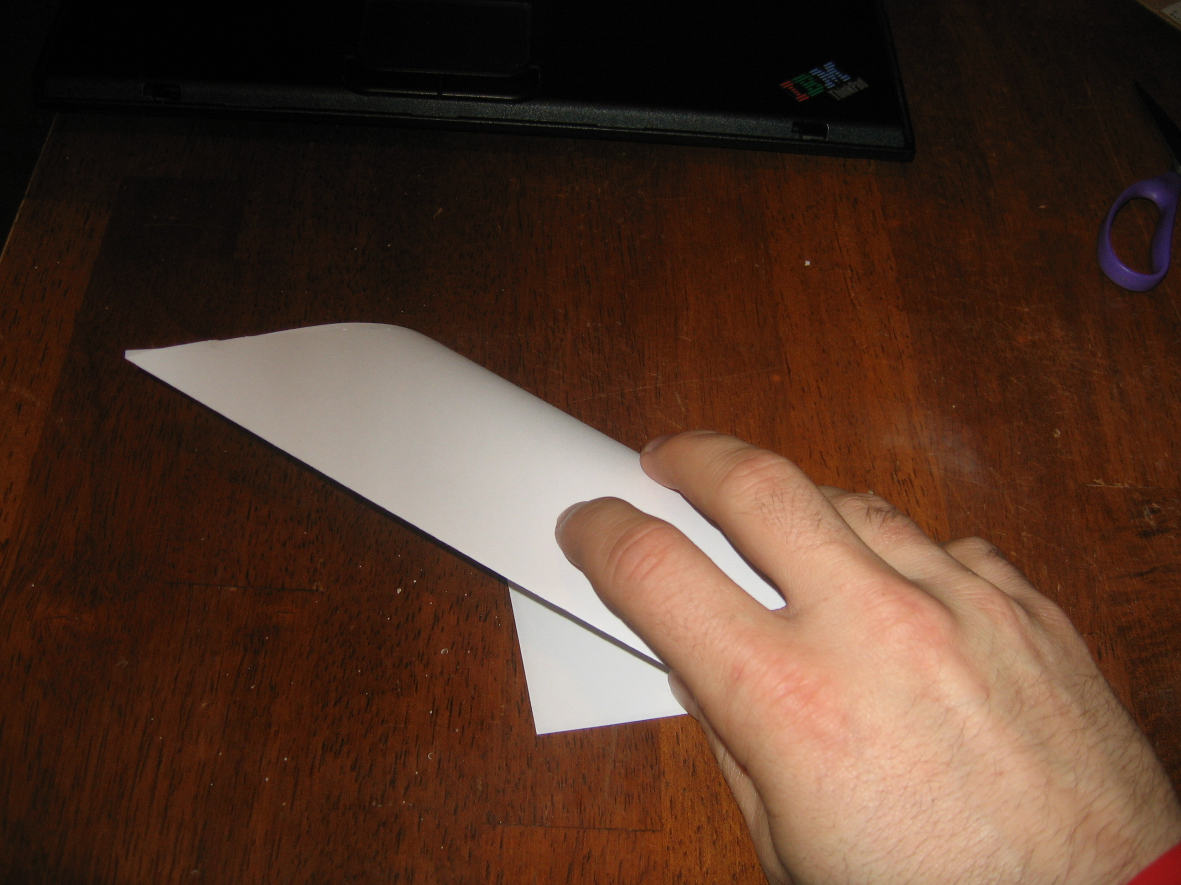
Step 4: Fold in half again in Same Direction (once again not symmetrically) | 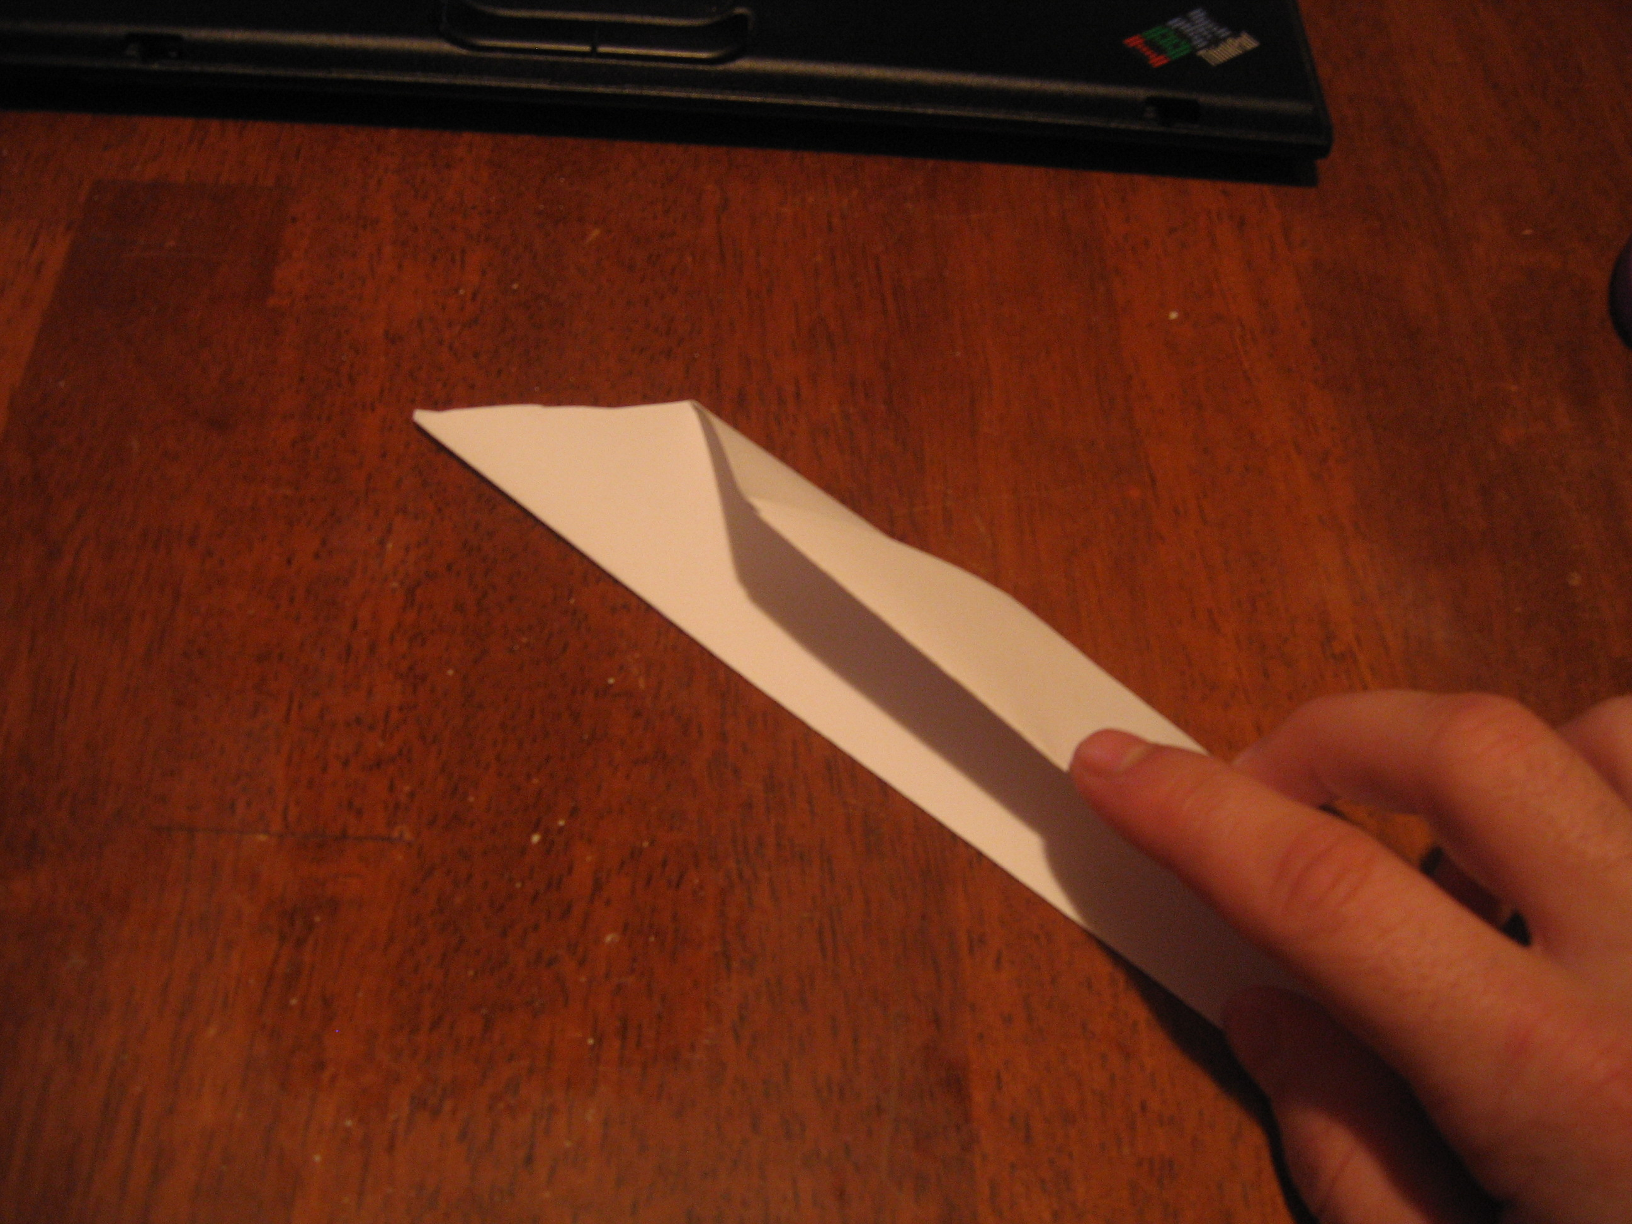
Step 5: Completely Unfold | 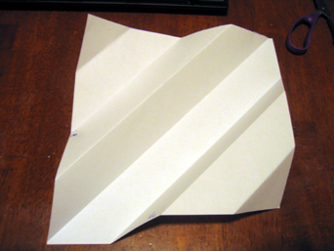
Step 6: Repeat Steps 2-5 for the other two corners (the 1st diagonal connects them)

Step 7: Place paper Oriented in a Diamond (there should be Straight lines up and down) | 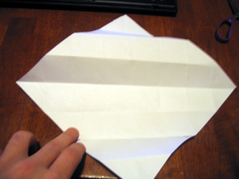
Step 8: Cut along the line to the left and right of the centerline, two boxes down starting where the line starts. Should now have what looks like a house (an isosceles triangle on top, and a square [4 boxes] directly underneath). | 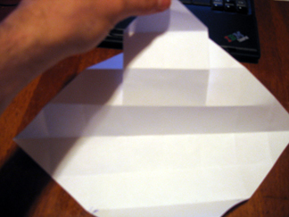
Step 9: Rotate the paper 180 degrees and Repeat Step 8 | 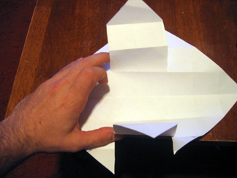
Step 10: Take the corners on the Left and the Right and have them meet in the Center. | 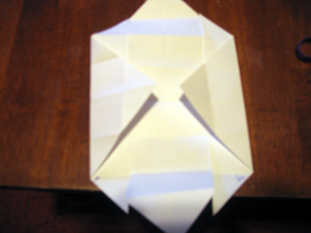
Step 11: Now take the free corners that were cut along the line in Step 8 and fold along their crease towards the center twice but keep them sticking up the second time | 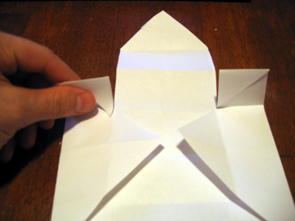
Step 12: Have the sides sticking up meet towards the center and tape across the two | 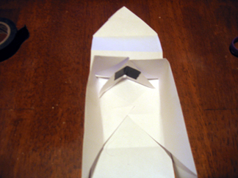
Step 13: Repeat Steps 11 & 12 for the sides cut in Step 9 | 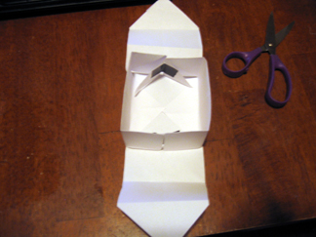
Step 14: Take the remaining pieces and fold on top of the new “walls” and then on again to meet the pervious corners in the center. | 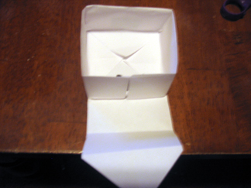
Step 15: Place a piece of tape in the center where the four corners meet and you’re done. | 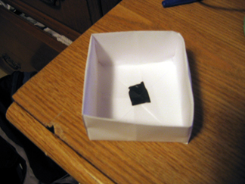

Math Curriculum Connections:

This approach resulted in a large scale pyramid built collectively, with all students participating. The size of the pyramid is determined by selecting the number of levels required. For example if you want 4 levels you would need 30 blocks because each level squared is the amount of blocks for that level ($1^{2}+2^{2}+3^{2}+4^{2}$= 30). In this case we used 5 levels, which requires 55 pieces; this way each student would have the same amount to make (3) with one extra.
Possible connections include proportions, shapes, fractions, slope, graphing, and algebra. For example, when planning the size of the pyramid, you can teach graphing by having the students start with different sized squares of paper, and then building the blocks to so they can graph the relation between paper size and block size. Proportion and related topics (fractions, ratio) can be derived from this exercise as well. Pre-algebra could be introduced by having students compute the number of blocks required by a given number of levels, or vice-versa.

