Pre-Columbian Pyramid Surface Area Lesson Plan

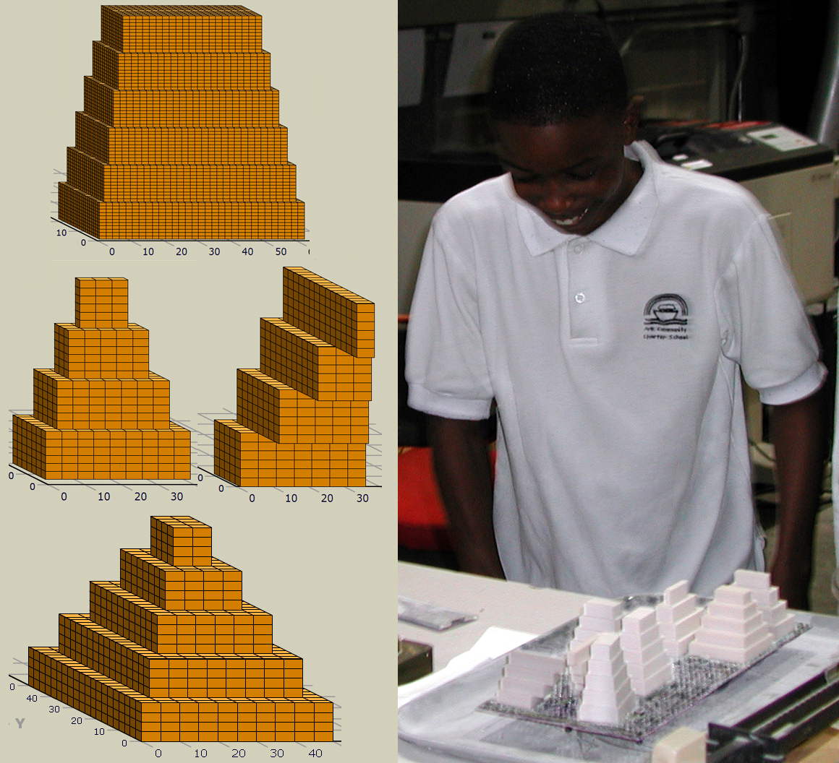

Day 1

Materials: Computers with access to the internet and the website
(http://www.ccd.rpi.edu/eglash/csdt/latino/pyramids/index.html)

Optional Materials: Mayan Pyramid Crossword (to accompany the website), access to
the video “Mexico Pyramids – Mexico” by Journeyman Pictures (if you can not find the video on DVD then it may be accessed online at http://www.youtube.com/watch?v=L9Mt1b38evg)

Lesson Plan:
(Steps 1 through 4 are optional)

- Have the students watch the video “Mexico Pyramids – Mexico” (video is approximately 6 minutes long). Optional: Mayan Pyramid Crossword Puzzle
- Students go to the website http://www.ccd.rpi.edu/eglash/csdt/latino/pyramids/index.html
- Have the students navigate through the section of the website called “Cultural Background”, this can be done using the tool bar on the left-hand side of the screen and the continue button on the bottom of the screen
- Have the students complete the Mayan Pyramid Crossword Puzzle, there are approximately two to three words on each section of the Cultural Background section
- Have the students open the 3D Pyramid Builder by clicking on the label on the left of the screen
- Students can play around with the program and the buttons to see how changing the values will provide a different pyramid. They should try making one of the pyramids located under “Goal Image”. If needed a tutorial can be given on how to make one of the pyramids, including how to make staircases.

Day 2

Materials: Computers with access to the internet and the website
(http://www.ccd.rpi.edu/eglash/csdt/latino/pyramids/index.html), enough copies of the data recording sheet for each student or group

Lesson Plan:

- Have the students go to the webpage http://www.ccd.rpi.edu/eglash/csdt/latino/pyramids/index.html and open up the 3D Pyramid Builder by selecting it on the left hand side of the page
- Give the students the goal of creating a one structure pyramid of their choice, let them use their imagination
- Have the students record the values for their final pyramid on the data recording sheet and hand it in
- Convert the values to SolidWorks files and submit to university manufacturing shop for creation of 3D models.

Day 3

Field trip to university manufacturing shop

Day 4

Materials: 3D models of the pyramids created by the students

Lesson Plan:

- Give the students the goal of figuring out the total surface area of their pyramid
- The students should then write up a method that can be used for any pyramid to quickly, easily and effectively calculate the total surface area
- Have a discussion with the class about all the methods that the students came up with for calculating surface area and what they discovered about surface area along the way

